Information about Optimist Regattas Events
We are delighted to have your QHYC youth member child represent Queen’s Harbour Yacht Club, our club, in local and regional sailing events. We suggest the following protocols and limitations.
SKILL LEVEL – Some regattas are designated as “Green Fleet” regattas designed for new sailors. Rules are lightly enforced and participation is as important as winning. Some regattas are, also, for Red, White, and/or Blue fleets and suitable only for more skilled sailors. Most regattas fall somewhere in between.
INVITATION: When a regatta chosen for QHYC, we will announce the event with the dates / costs. Then, our Sailing Director (Capt. Jack) will contact parents and invite sailors with skill levels matching the Regatta's fleet designation to participate. Our goal: Offer appropriate regatta opportunities for all.
EQUIPMENT LIMITS – At present, QHYC owns 5 Optimist Sailboats. This may limit the number of sailors who want to participate in a regatta. Assuming a regatta has all classes, we will contact the sailors with the best skills for the classes of Optimists (Red, White, Blue, and Green) designated for the regatta.
REGATTA COSTS – There are a number of fees associated with a regatta. And each regatta can be a little different. Below is a sample of what costs you can expect when participating in a regatta. Specific information will be available for each regatta.
- ENTRY-FEE – $10 to $75. Paid directly to the host Yacht Club, usually on-line. This fee is usually due in advance. The Notice of Race outlines the entry fee and what it covers (may include Lunch, Dinner, T-Shirt, Awards, etc.)
- COACHING FEE - Participating Yacht Clubs must cover the cost of providing staff and coach boats at regattas, and includes Regatta assistance with set up and rigging. A nominal coaching fee may be charged for these expenses, paid for by your dues and any specific youth assessments.
- EQUIPMENT FEE – There is no fee for your child to use QHYC boats and equipment.
- TRANSPORTATION FEE /OPTION - There is no fee for families willing / able to transport Opti and equipment to regatta on their own. In the alternative, sailing club staff will transport your Opti to and from a regatta for your sailor's use. The fee to sailor's family, if any, for this service will be noted when regatta is advertised. There is no transportation fee for regatta at QH.
- DAMAGE/CLEANING FEE –Sailors and their families are expected to care for and return equipment in reasonable condition, wear and tear excepted. While it is understood that youth boats get “banged up” from time to time, any unusual damage due to e.g. member transportation, and any repair cost, is understood to be a matter to be discussed with club.
EVENTS – From time to time, QHYC will offer your child (and/or you) the opportunity to participate in a field trip, outing, or sailing event, family picnic (Not to be confused with a regatta). Eligibility and fees (if any) will be outlined in an event notice or sign-up form.
Our sailors participated in three regattas last year. We look forward to more enjoyable regattas ahead!
Gil Wright, Sailing Committee
904-742-0556; wrightgp@comcast.net

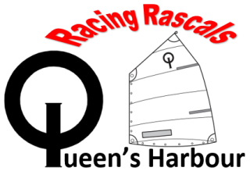
Cowford Cup

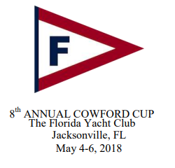
QHYC
Racing Rascals
Sailing Team
COWFORD CUP REGATTA

Regatta Fee $75.00
Coaching Fee $ 0.00
Equipment Fee $ 0.00
Transport Fee $50.00

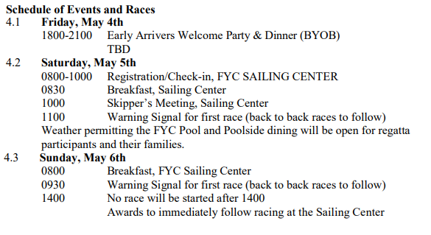
Green Fleet and Advanced Sailors welcome.

QHYC members: Contact Captain Jack if you would like to race.
To register: regattanetwork.com

*Regatta Fee-Register / Pay FYC-on line; QHYC Coaching /Equipment/Transport Fees
(If any): Payable (in advance) to QHYC.
Capt. Jack Feeney – SailQueensHarbour@Gmail.com – 904-568-8405

FREE SAILING / PICNIC DAY for QHYC Members / POA Residents

Sunday, April 29th
2-6 PM

(in alphabetical order…)

Fun & Games
Hotdogs
Kayaks
Racing
Swimming
(in the Pool)
Sailing
Tug of War

(At Marina & Sailing Center)

RSVP Required – Sign up at SailQH.com
Members / POA Residents may bring guests
Call Capt. Jack for more info 904-568-8405

Raffle: New and Renewal FY 18 Junior Memberships

Our sailors will take your youth sailing. Opportunity to renew / sign up youth as 2018 Junior Yacht Club Members [and/or] for POA Parents to join Yacht Club, which membership includes full Junior YC Membership for all their youth.

